

**Process Scheduler Modification**

## Objective: In this lab you will build a LKM called “sched_dumper” that will search for a process with a specific name setsched. It will modify the scheduling policy and priority.

Reference: LKI/Lab6 folder

1. The setsched program should set its own process priority in usermode (as root) and scheduling policy as soon as it executes.

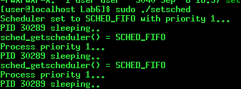

1. Your LKM should search for this process and modify its scheduling policy to SCHED_RR and set a process priority of -20 (user mode). Once the scheduling policy and priority is modified by the LKM, the user mode process “setsched” should reflect the change and automatically update the result.

